CS 350 Data Structure

Homework 2: Bubble Sort and Structure (100 points)

- Create an integer array of 50 elements. Each element is a random number between 1 and 10000.
- Use bubble sort to sort this array from low to high.
- Print the sorted array by having 5 elements per line.
- Create a random value between 1 and 1000. Use binary search to find out whether this target is in your array.

- Write a C codeblock to do the following:

- Define a datatype called NODETYPE which has three components: an integer called “key”, a string called “name”, and a pointer called “next” which points to a value of NODETYPE.

- Define a pointer called “ptrNode” which points to a NODETYPE value.

- Use malloc function to give a value to “ptrNode”

- Recall your key and name assigned during class. Pass these values to the node pointed by ptrNode.

- Use printf ( ) to print the key an

#include <stdio.h>
#include <stdlib.h>
#include <time.h>

#define NOT_FOUND -1
int search (int chap[], int target);

int main()
{
int chap[50];
int i,j;
int temp =0;
int num;
int index;
int target;
srand(time(NULL));
//create element for array
for (i =0; i<50; i++) {
num = rand() % 1000 +1;
chap[i] = num;
}
// generate bubble sorted array
for (i=0; i<50; i++) {

for (j=0; j< 50-1; j++) {

if (chap[j] > chap[j+1])
{
temp = chap[j];
chap[j] = chap[j+1];
chap[j+1] = temp;

}
}
}
for (j=0; j<50; j++){

printf("%d\n", chap[j] );

}

// searching random target from sorted array
index = search(chap, target);
for (j=0; j<50; j++){

target = chap[j];
printf("%d\n enter target number", chap[j] );
printf("%d%s%d\n", j, " ===> ", chap[j]);
printf("%d\n",chap[j]);
if (index != NOT_FOUND){
printf("%s%d\n", "Target is found at index: ===> ", index);
} else {
printf("%s\n","Target is not found :(");
}
}
return 0;

}

int search (int chap[], int target){

// index postion of first, middle and last
int first = 0;
int last = 1000;
int middle = (first + last) /2;
int i;

// if index of first is smaller or equal than index of last perform action
while (first <= last){

printf("%s%d\n", "FIRST : ", first);
printf("%s%d\n", "MIDDLE : ", middle);
printf("%s%d\n", "LAST : ", last);
printf("%s%d\n", "TARGET : ", target);
printf("%s\n", "==================================");

// check value at index of first is same as target or not
if(chap[first] == target){
return first;
}
// check value at index of last is same as target or not
if(chap[last] == target){
return last;
}

// if target value is less than value at middle index decress middle index by 1
// if target value is greater than value at middle index increase middle index by 1
if(target < chap[middle]){
last = middle - 1;
} else if(target > chap[middle]){
first = middle + 1;
} else {
return middle;
}
middle = (first + last)/2;
}
return -1;
}
- 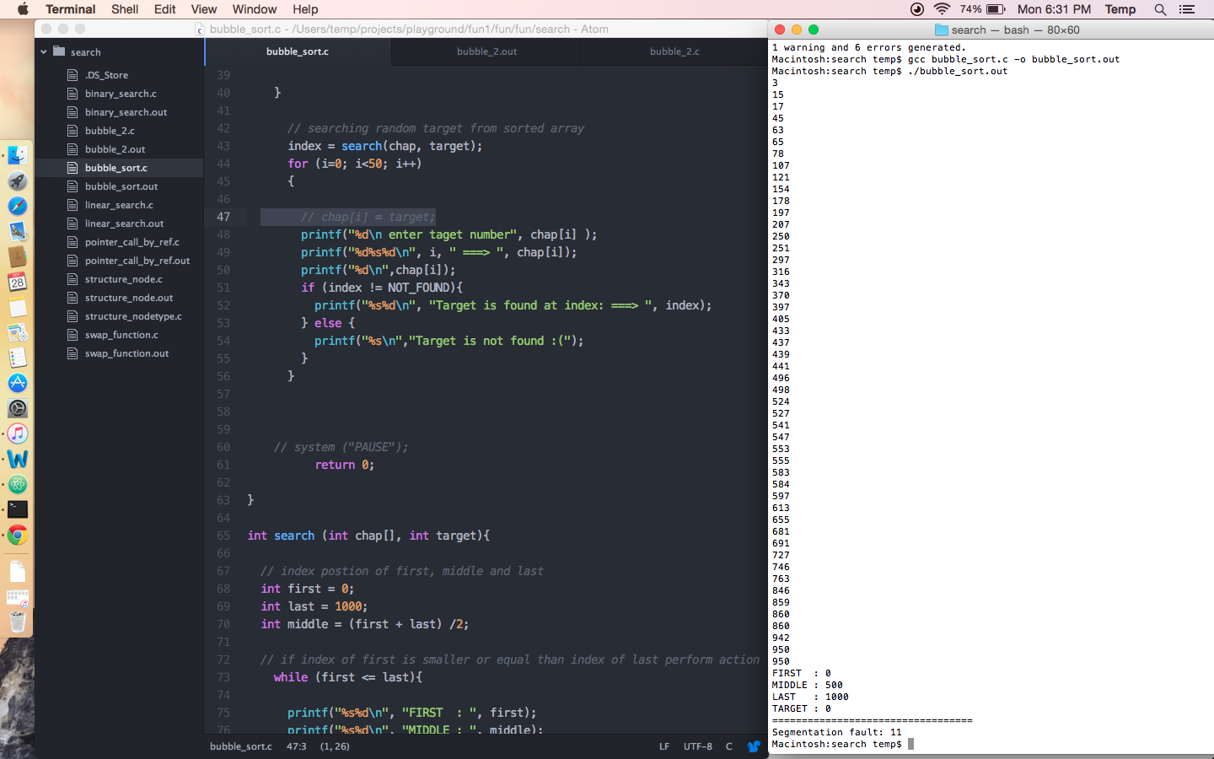d name of the node pointed by pt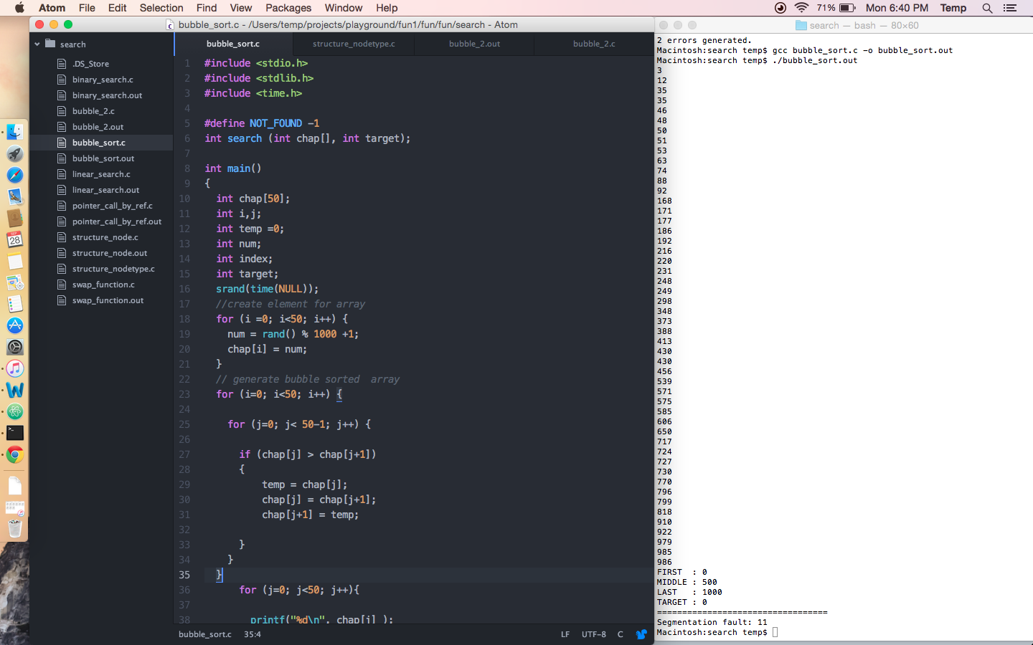rNode.

// structure_nodetype
#include <stdio.h>
#include <stdlib.h>
//strucure type
typedef struct nodetype{
int key;
char name [50];
struct nodetype *next;

} NODETYPE;

int main()
{
int key;
char name [50];
// struct nodetype key = 6;
// struct nodetype name = 'shruti';
struct nodetype *ptrNode;

ptrNode = (NODETYPE*)malloc(sizeof (struct nodetype));

printf("key: %d & name : %c\n", nodetype.key,nodetype.name);
// printf("value: %d\n", nodearray[i].value);

return 0;
}

